**SQL Task Output Screenshots**

**Exercise -1:**

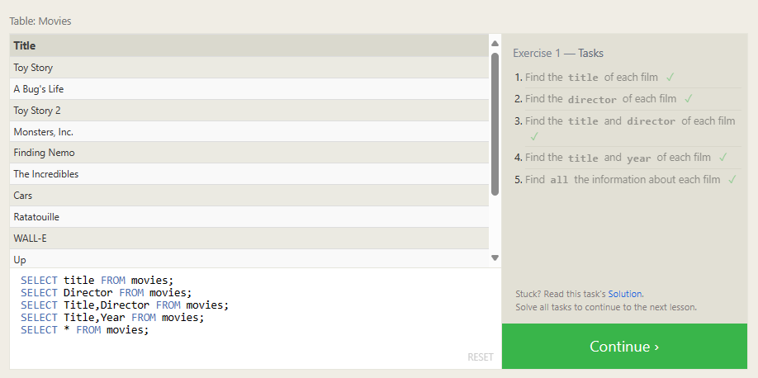

**Exercise -2:**

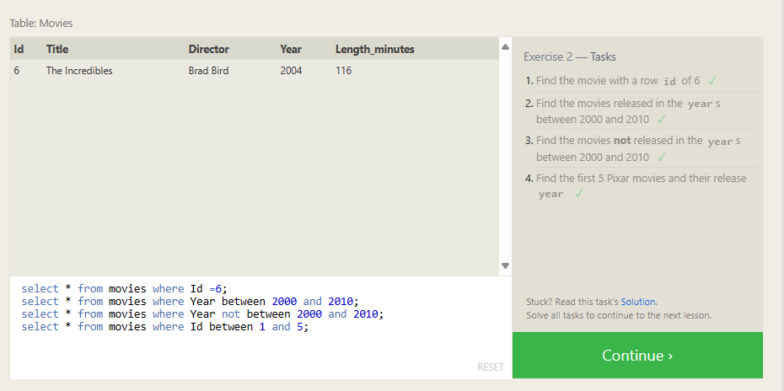

**Exercise – 3:**

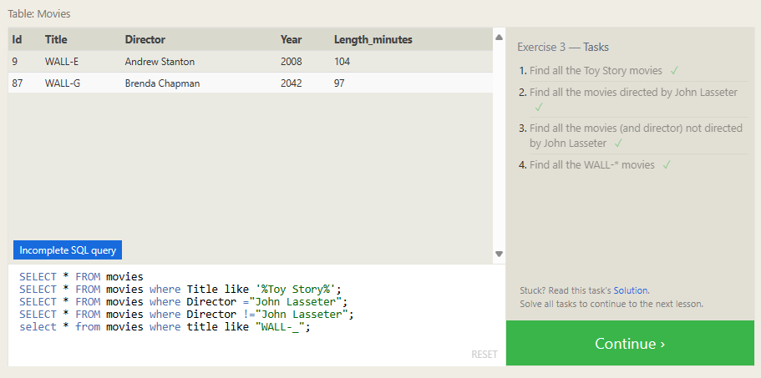

**Exercise – 4:**

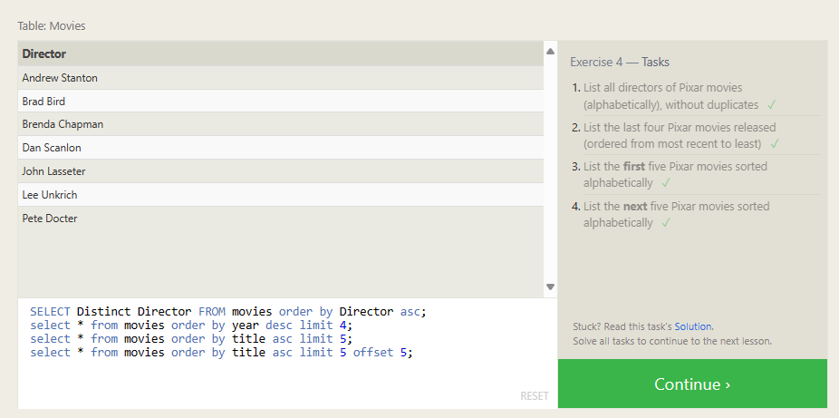

**SQL Review Tasks:**

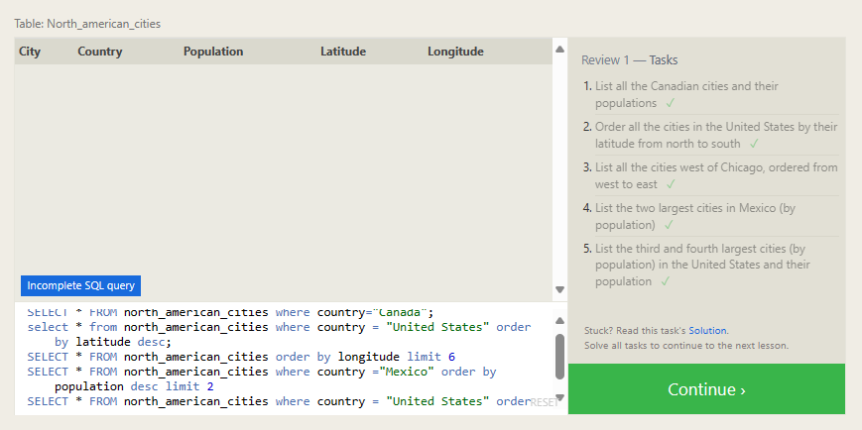

All queries related to review task: (All the queries are not visible in the screenshot)

1. SELECT * FROM north_american_cities where country="Canada";
2. select * from north_american_cities where country = "United States" order by latitude desc;
3. SELECT * FROM north_american_cities order by longitude limit 6
4. SELECT * FROM north_american_cities where country ="Mexico" order by population desc limit 2
5. SELECT * FROM north_american_cities where country = "United States" order by population desc limit 2 offset 2

**Exercise – 6:**

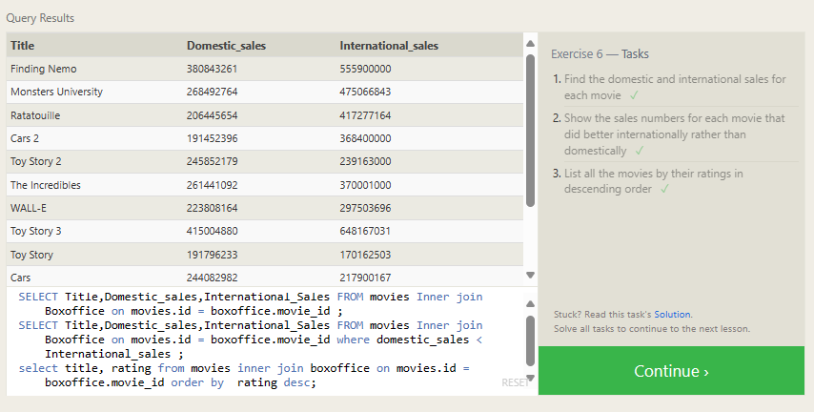

**Exercise – 7:**

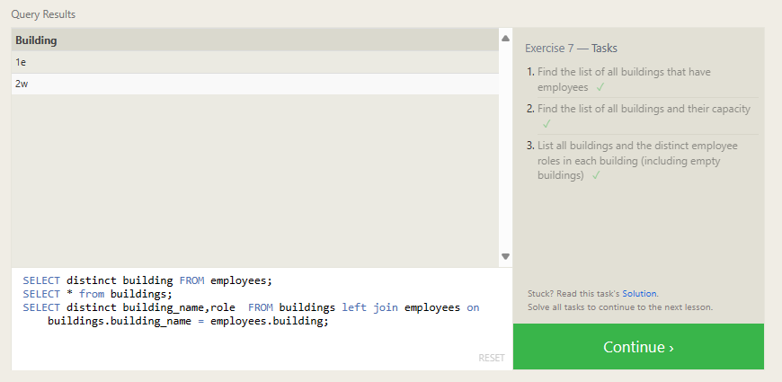

**Exercise – 8:**

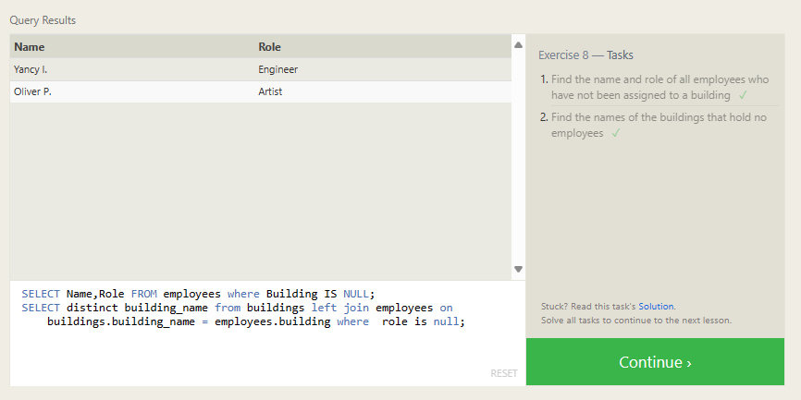

**Exercise – 9:**

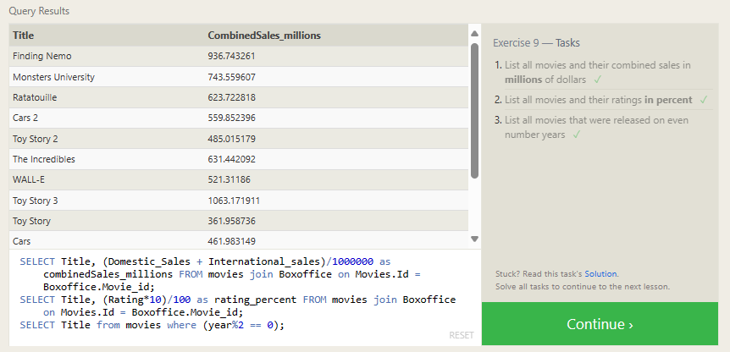

**Exercise – 10:**

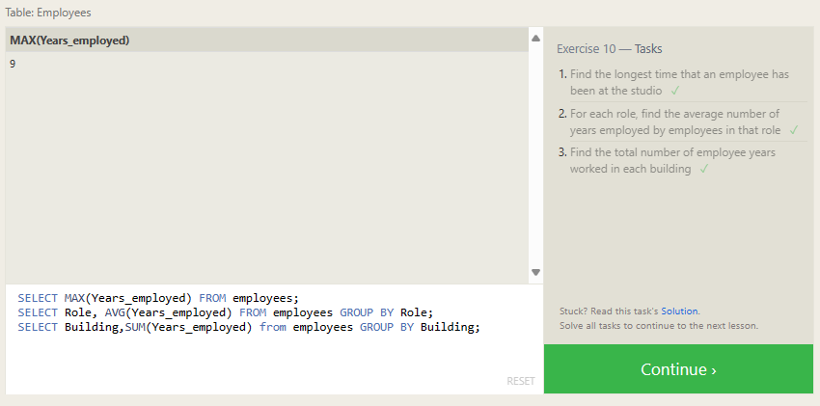

**Exercise – 11:**

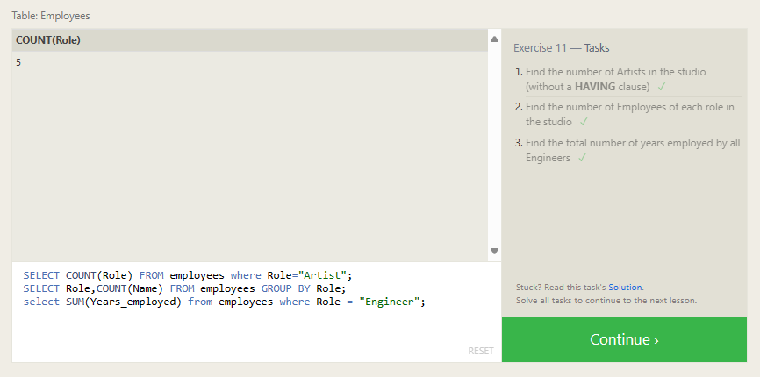

**Exercise – 12:**

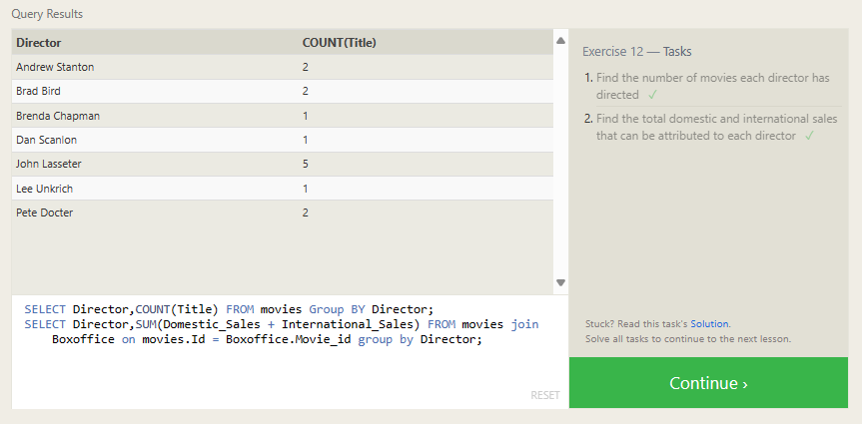

**Exercise – 13:**

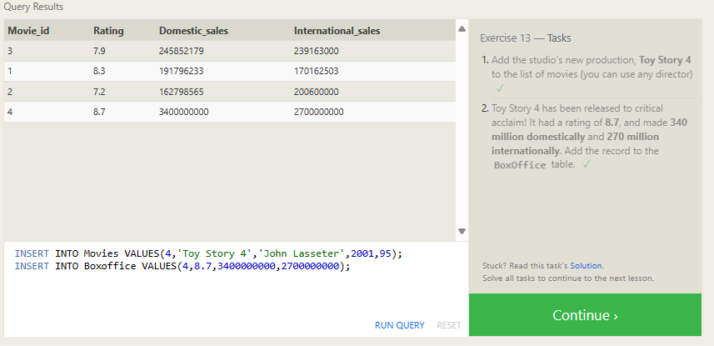

**Exercise – 14:**

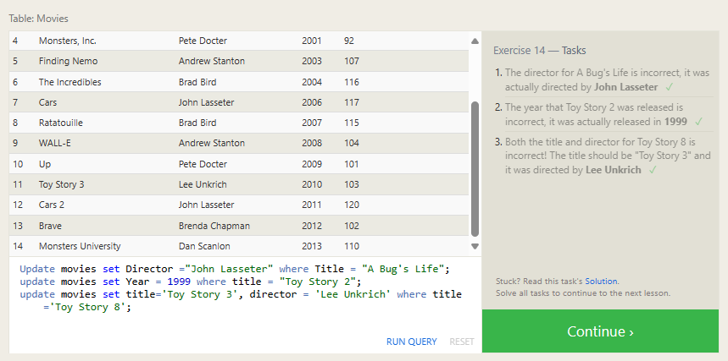

**Exercise – 15:**

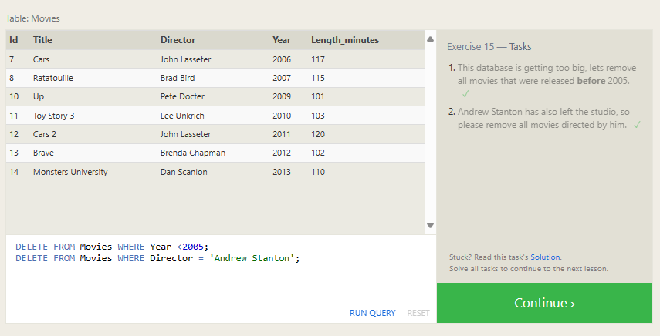

**Exercise – 16:**

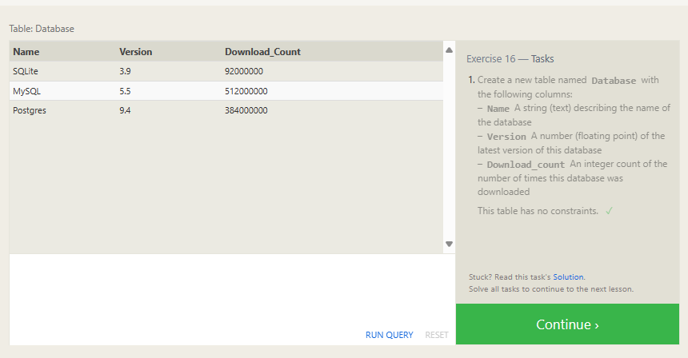

**Exercise – 17:**

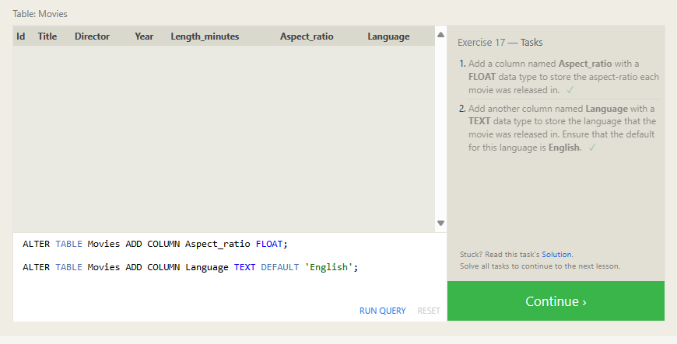

**Exercise – 18:**

